

**Supplementary Fig. 1.** Aclust tree of representative O-Lig sequences. The four subfamilies are shown in red, green, turquoise, and yellow. Seed sequences are marked with a red bar.



**Supplementary Fig. 2.** Phylogenetic tree of representative WadA homologs from the GTxx3 family, showing the taxonomic origin of the sequences and the domain modularity. N-terminal GT25 domains are shown in blue and GTxx3 domain in purple. The two-domain sequences segregate from proteins with a single domain GTxx3, suggesting co-evolution of the two domains.

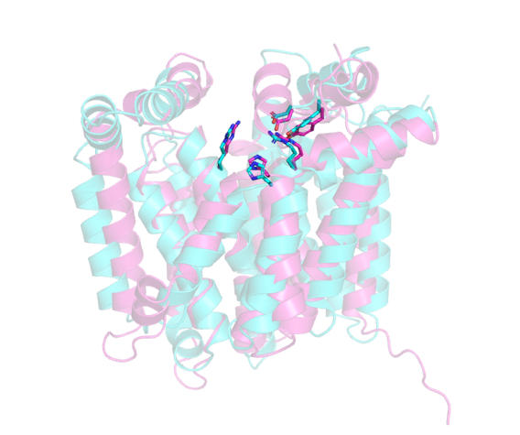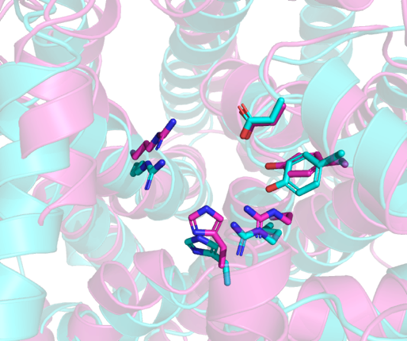

ABB29906.1 and AHB32334.1. Sequence identity: 21.4% over 421 residues. RMSD: 4.3 over 304 residues.

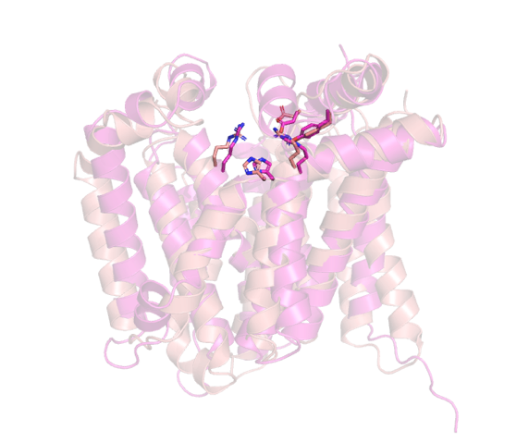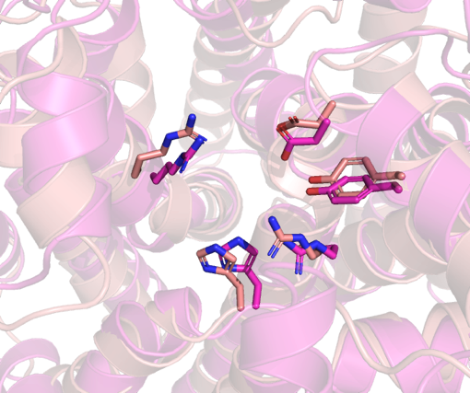

ACA24821.1 and AHB32334.1. Sequence identity: 21.7% over 415 residues. RMSD: 3.9 over 312 residues.

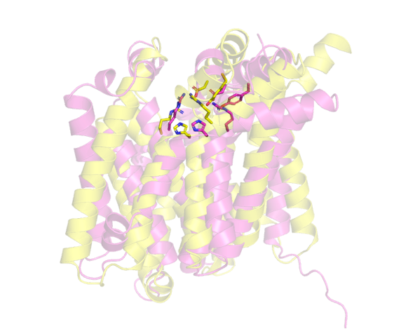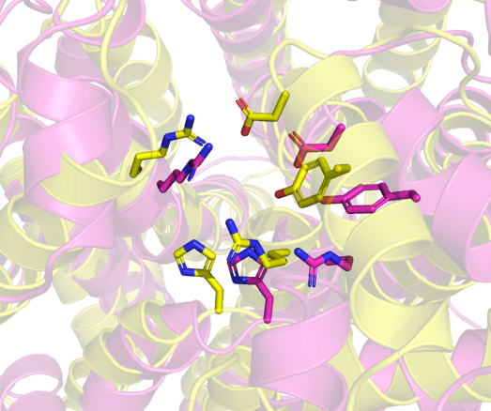

AHB32215.1 and AHB32334.1. Sequence identity: 24.3% over 403 residues. RMSD: 5.1 over 248 residues.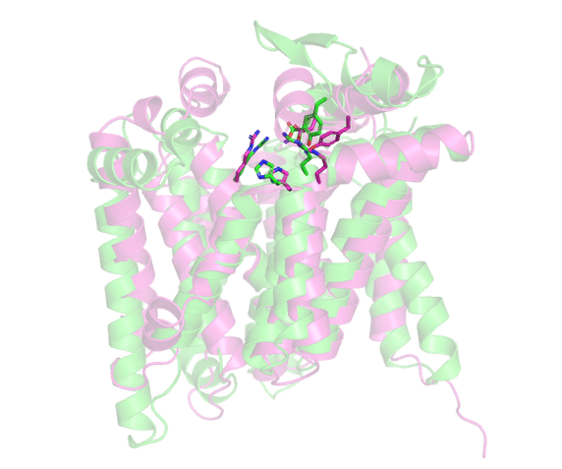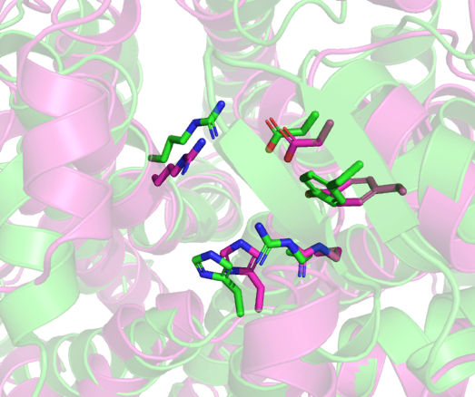

CAI34008.1 and AHB32334.1. Sequence identity: 22.4% over 416 residues. RMSD: 4.2 over 320 residues.

**Supplementary Fig. 3.** Structural superimpositions of AlphaFold models of distantly related BP-Pols from family GTxx4 aligned to a reference, AHB32334.1. AHB32334.1 is shown in pink in all of the figures.

**GTxx4:**



**GTxx5:**



**GTxx6:**



**GTxx7:**



**GTxx8:**



**GTxx9:**



**GTx10:**



**GTx11:**



**GTx12:**



**GTx13:**



**GTx14:**



**GTx15:**



**GTx16:**



**GTx17:**



**Supplementary Fig. 4.** Phylogenetic trees of the BP-Pols in each family with structures of the corresponding sugar repeat units in SNFG format visualized using iTOL. The tree for GTxx4 is split in three pages due to its size.

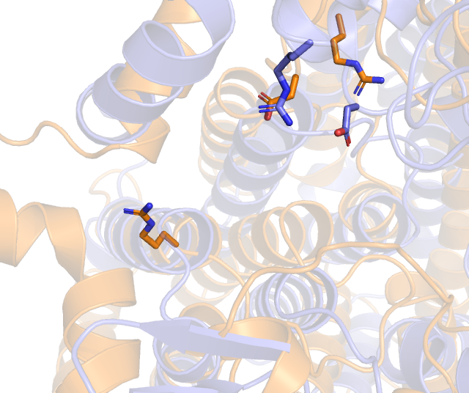

dd

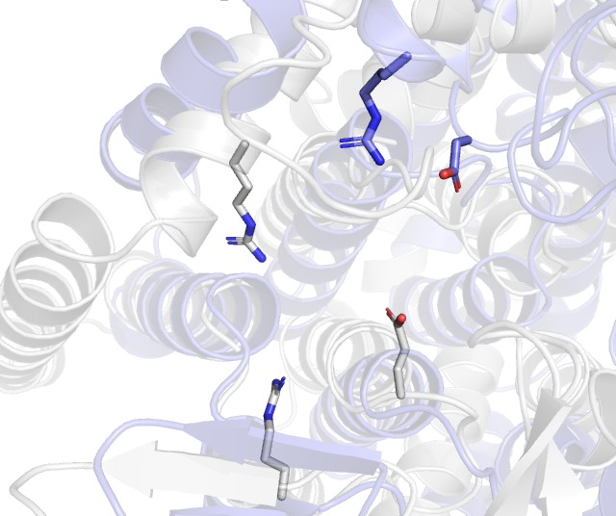

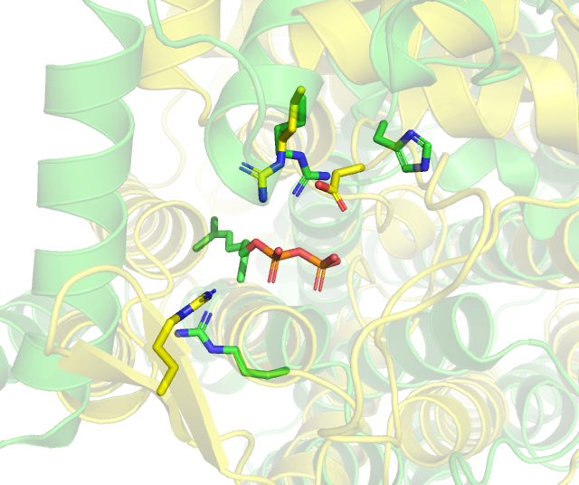

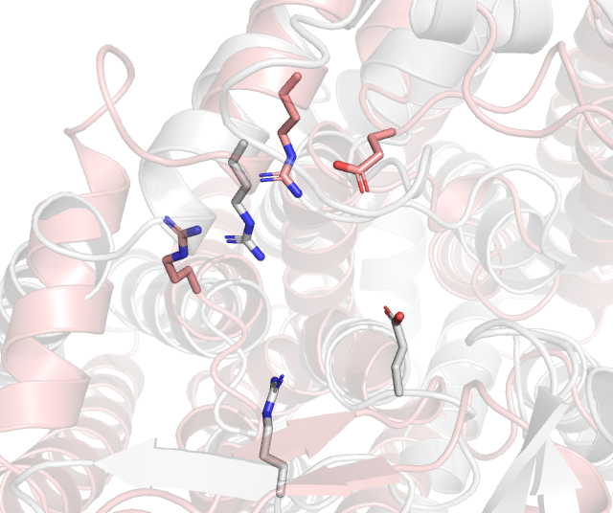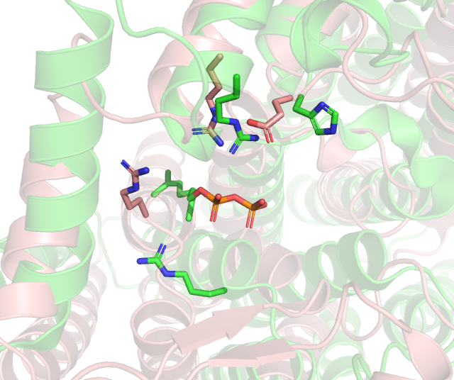

**Supplementary Fig. 5.** Structural superimpositions of AlphaFold models of representative sequences from each family in clan GT-CB1.

|  |  |
| --- | --- |
| **Species** | **Accession number** |
| Salmonella enterica | AAO71288.1 |
| Salmonella enterica | AAV79366.1 |
| Salmonella enterica | ACF62503.1 |
| Salmonella enterica | ACF69468.1 |
| Salmonella enterica | ACF92659.1 |
| Salmonella enterica | CAR61594.1 |
| Salmonella enterica | ACH77456.1 |
| Salmonella enterica | CAR39498.1 |
| Salmonella enterica | AAL22572.1 |
| Vibrio cholerae | AAL76923.1 |
| Taylorella equigenitalis | ADU91200.1 |
| Haemophilus parainfluenzae | EGC72795.1 |
| Aeromonas salmonicida | WP_005318160.1 |
| Vibrio cholerae | AAL77359.1 |
| Mycetohabitans rhizoxinica | CBW75858.1 |
| Pectobacterium atrosepticum | CAG73082.1 |
| Escherichia coli | AAB18599.1 |
| Erwinia amylovora | CBA19033.1 |
| Xenorhabdus bovienii | WP_012990589.1 |
| Proteus mirabilis | CAR46213.1 |
| Providencia rettgeri | EFE51464.1 |
| Pseudomonas aeruginosa | AAG08384.1 |
| Klebsiella pneumoniae | BAH65745.1 |
| Vibrio cholerae | AAL77364.1 |
| Leptospira borgpetersenii | WP_011670128.1 |
| Escherichia coli | AAC69661.1 |
| Escherichia coli | AAA24524.1 |
| Salmonella enterica | AAA27206.1 |
| Salmonella enterica | AAS22256.1 |
| Salmonella enterica | NP_462613.1 |
| Salmonella enterica | AAS22257.1 |
| Escherichia coli | CAR10296.1 |
| Escherichia coli | BAI33254.1 |
| Escherichia coli | AAC69671.1 |
| Escherichia coli | AAC69682.1 |
| Cupriavidus metallidurans | WP_011517284.1 |
| Escherichia coli | AAC69648.1 |

**Supplementary Table 1.** O-Lig seeds. List of seed sequences used for creation of the O-Lig family.

|  |  |  |  |
| --- | --- | --- | --- |
| **Species** | **Serotype** | **Accession number** | **CAZy family** |
| Acinetobacter baumannii | O1 | AHB32215.1 | GTxx4 |
| Acinetobacter nosocomialis | O2 | AHB32538.1 |  |
| Acinetobacter baumannii | O3 | AHB32563.2 | GTx11 |
| Acinetobacter nosocomialis | O4 | AHB32666.1 |  |
| Acinetobacter baumannii | O5 | AHB32242.2 |  |
| Acinetobacter baumannii | O6 | AHB32267.1 |  |
| Acinetobacter baumannii | O8 | AHB32311.1 |  |
| Acinetobacter baumannii | O10 | AHB32411.1 | GTx12 |
| Acinetobacter nosocomialis | O11 | AHB32510.1 | GTx16 |
| Acinetobacter baumannii | O12 | AHB32774.1 |  |
| Acinetobacter baumannii | O13 | AHB32386.1 |  |
| Acinetobacter baumannii | O14 | AHB32687.1 | GTxx5 |
| Acinetobacter baumannii | O15 | AHB32490.1 | GTx16 |
| Acinetobacter baumannii | O17 | AHB32462.1 | GTxx4 |
| Acinetobacter baumannii | O18 | AHB32334.1 | GTxx4 |
| Acinetobacter baumannii | O19 | AHB32832.1 |  |
| Acinetobacter baumannii | O20 | AHB32614.2 |  |
| Acinetobacter baumannii | O21 | AHB32283.1 | GTxx4 |
| Acinetobacter baumannii | O22 | AHB32438.2 |  |
| Acinetobacter baumannii | O23 | AHB32637.1 | GTxx4 |
| Acinetobacter baumannii | O24 | AHB32586.1 |  |
| Acinetobacter baumannii | O25 | AHB32861.1 | GTxx4 |
| Acinetobacter baumannii | O26 | AHB32799.1 | GTxx4 |
| Acinetobacter baumannii | O27 | AHB32357.1 |  |
| Streptococcus pneumoniae | 1 | CAI32705.1 |  |
| Streptococcus pneumoniae | 2 | CAI32727.1 |  |
| Streptococcus pneumoniae | 4 | CAI32772.1 | GTx16 |
| Streptococcus pneumoniae | 5 | CAI32797.1 |  |
| Streptococcus pneumoniae | 6A | CAI32823.1 | GTx13 |
| Streptococcus pneumoniae | 6B | CAI32843.1 | GTx13 |
| Streptococcus pneumoniae | 7A | CAI32867.1 |  |
| Streptococcus pneumoniae | 7B | CAI32889.1 |  |
| Streptococcus pneumoniae | 7C | CAI32910.1 |  |
| Streptococcus pneumoniae | 7F | CAI32935.1 |  |
| Streptococcus pneumoniae | 8 | CAI32957.1 | GTxx7 |
| Streptococcus pneumoniae | 9A | CAI32973.1 |  |
| Streptococcus pneumoniae | 9L | CAI32993.1 |  |
| Streptococcus pneumoniae | 9N | CAI33011.1 |  |
| Streptococcus pneumoniae | 9V | CAI33029.1 |  |
| Streptococcus pneumoniae | 10F | CAI33105.1 |  |
| Streptococcus pneumoniae | 10A | CAI33048.1 |  |
| Streptococcus pneumoniae | 10B | CAI34733.1 |  |
| Streptococcus pneumoniae | 10C | CAI33084.1 |  |
| Streptococcus pneumoniae | 11F | CAI33207.1 |  |
| Streptococcus pneumoniae | 11A | CAI33128.1 |  |
| Streptococcus pneumoniae | 11B | CAI33149.1 |  |
| Streptococcus pneumoniae | 11C | CAI33169.1 |  |
| Streptococcus pneumoniae | 11D | CAI33188.1 |  |
| Streptococcus pneumoniae | 12F | CAI33278.1 |  |
| Streptococcus pneumoniae | 12A | CAI33226.1 |  |
| Streptococcus pneumoniae | 12B | CAI33252.1 |  |
| Streptococcus pneumoniae | 13 | CAI33309.1 | GTxx7 |
| Streptococcus pneumoniae | 14 | CAI33324.1 |  |
| Streptococcus pneumoniae | 15F | CAI33412.1 |  |
| Streptococcus pneumoniae | 15A | CAI33343.1 |  |
| Streptococcus pneumoniae | 15B | CAI33366.1 |  |
| Streptococcus pneumoniae | 15C | CAI33389.1 |  |
| Streptococcus pneumoniae | 16F | CAI33466.1 |  |
| Streptococcus pneumoniae | 16A | CAI33441.1 | GTxx7 |
| Streptococcus pneumoniae | 17F | CAI33515.1 |  |
| Streptococcus pneumoniae | 17A | CAI33491.1 |  |
| Streptococcus pneumoniae | 18F | CAI33610.1 |  |
| Streptococcus pneumoniae | 18A | CAI33537.1 |  |
| Streptococcus pneumoniae | 18B | CAI33561.1 |  |
| Streptococcus pneumoniae | 18C | CAI33585.1 |  |
| Streptococcus pneumoniae | 19F | CAI33700.1 | GTx13 |
| Streptococcus pneumoniae | 19A | CAI33631.1 | GTx13 |
| Streptococcus pneumoniae | 19B | CAI33652.1 |  |
| Streptococcus pneumoniae | 19C | CAI33675.1 |  |
| Streptococcus pneumoniae | 20 | CAI33718.1 | GTxx4 |
| Streptococcus pneumoniae | 21 | CAI33745.1 |  |
| Streptococcus pneumoniae | 22F | CAI33798.1 |  |
| Streptococcus pneumoniae | 22A | CAI33774.1 |  |
| Streptococcus pneumoniae | 23F | CAI33862.1 |  |
| Streptococcus pneumoniae | 23A | CAI33817.1 |  |
| Streptococcus pneumoniae | 23B | CAI33840.1 |  |
| Streptococcus pneumoniae | 24F | CAI33941.1 |  |
| Streptococcus pneumoniae | 24A | CAI33890.1 |  |
| Streptococcus pneumoniae | 24B | CAI33915.1 |  |
| Streptococcus pneumoniae | 25F | CAI33983.1 | GTx16 |
| Streptococcus pneumoniae | 25A | CAI33966.2 | GTx16 |
| Streptococcus pneumoniae | 27 | CAI34008.1 | GTxx4 |
| Streptococcus pneumoniae | 28F | CAI34057.2 |  |
| Streptococcus pneumoniae | 28A | CAI34032.1 |  |
| Streptococcus pneumoniae | 29 | CAI34080.1 | GTxx7 |
| Streptococcus pneumoniae | 31 | CAI34099.1 |  |
| Streptococcus pneumoniae | 32F | CAI34150.1 | GTx10 |
| Streptococcus pneumoniae | 32A | CAI34124.1 | GTx10 |
| Streptococcus pneumoniae | 33F | CAI34254.1 | GTxx9 |
| Streptococcus pneumoniae | 33A | CAI34177.1 | GTxx9 |
| Streptococcus pneumoniae | 33B | CAI34198.1 | GTxx9 |
| Streptococcus pneumoniae | 33C | CAI34217.1 | GTxx9 |
| Streptococcus pneumoniae | 33D | CAI34236.1 | GTxx9 |
| Streptococcus pneumoniae | 34 | CAI34269.1 | GTx13 |
| Streptococcus pneumoniae | 35F | CAI34348.1 | GTxx7 |
| Streptococcus pneumoniae | 35A | CAI34286.1 | GTxx7 |
| Streptococcus pneumoniae | 35B | CAI34310.1 | GTxx7 |
| Streptococcus pneumoniae | 35C | CAI34328.1 | GTxx7 |
| Streptococcus pneumoniae | 36 | CAI34369.1 | GTxx7 |
| Streptococcus pneumoniae | 38 | CAI34407.1 | GTx16 |
| Streptococcus pneumoniae | 39 | CAI34436.1 |  |
| Streptococcus pneumoniae | 40 | CAI34454.1 |  |
| Streptococcus pneumoniae | 41F | CAI34498.1 |  |
| Streptococcus pneumoniae | 41A | CAI34475.1 |  |
| Streptococcus pneumoniae | 42 | CAI34519.1 | GTxx7 |
| Streptococcus pneumoniae | 43 | CAI34544.1 | GTxx7 |
| Streptococcus pneumoniae | 44 | CAI34753.1 |  |
| Streptococcus pneumoniae | 45 | CAI34587.1 |  |
| Streptococcus pneumoniae | 46 | CAI34613.1 |  |
| Streptococcus pneumoniae | 47F | CAI34657.1 | GTxx7 |
| Streptococcus pneumoniae | 47A | CAI34641.1 | GTxx7 |
| Streptococcus pneumoniae | 48 | CAI34680.1 | GTx10 |
| Yersinia pseudotuberculosis | O:1a | AAN23041.1 |  |
| Yersinia pseudotuberculosis | O:1b | CAB63298.1 | GTx17 |
| Yersinia pseudotuberculosis | O:1c | ADI59429.1 |  |
| Yersinia pseudotuberculosis | O:2a | AAN23078.1 |  |
| Yersinia pseudotuberculosis | O:2b | ADI59445.1 |  |
| Yersinia pseudotuberculosis | O:2c | AKA20935.1 |  |
| Yersinia pseudotuberculosis | O:3 | AKA20948.1 | GTx17 |
| Yersinia pseudotuberculosis | O:4a | AKA20966.1 |  |
| Yersinia pseudotuberculosis | O:4b | AAN23057.1 |  |
| Yersinia pseudotuberculosis | O:5a | AKA20981.1 |  |
| Yersinia pseudotuberculosis | O:5b | AKA20999.1 |  |
| Yersinia pseudotuberculosis | O:6 | AEP25500.1 |  |
| Yersinia pseudotuberculosis | O:7 | AEP25477.1 |  |
| Yersinia pseudotuberculosis | O:8 | AKL88154.1 |  |
| Yersinia similis | O:9 | CDF66396.1 | GTx15 |
| Yersinia pseudotuberculosis | O:10 | ADX97403.1 |  |
| Yersinia pseudotuberculosis | O:11 | ACV52983.1 | GTx17 |
| Yersinia similis | O:12 | AFV46136.1 | GTxx4 |
| Yersinia pseudotuberculosis | O:14 | ACV53000.1 | GTx17 |
| Yersinia pseudotuberculosis | O:15 | CAX18360.1 |  |
| Escherichia coli | O1 | ADC54929.1 |  |
| Escherichia coli | O2 | ADC54941.1 |  |
| Escherichia coli | O3 | ACH97152.1 |  |
| Escherichia coli | O4 | AAT85653.1 | GTxx4 |
| Escherichia coli | O5 | BAQ00569.1 | GTx14 |
| Escherichia coli | O6 | BAQ00581.1 | GTx16 |
| Escherichia coli | O7 | AAD44158.1 | GTx17 |
| Escherichia coli | O10 | BAQ00622.1 | GTxx4 |
| Escherichia coli | O11 | ADV17650.1 | GTxx6 |
| Escherichia coli | O12 | BAQ00634.1 |  |
| Escherichia coli | O13 | BAQ02138.1 | GTxx8 |
| Escherichia coli | O15 | AAV74543.1 |  |
| Escherichia coli | O16 | BAQ00653.1 | GTx13 |
| Escherichia coli | O17 | BAQ02105.1 |  |
| Escherichia coli | O18ab | BAQ00669.1 | GTx13 |
| Escherichia coli | O18ac | BAQ00687.1 | GTx13 |
| Escherichia coli | O19 | BAQ00705.1 | GTx13 |
| Escherichia coli | O20 | BAQ00719.1 |  |
| Escherichia coli | O21 | ACH97162.1 |  |
| Escherichia coli | O22 | BAQ00736.1 |  |
| Escherichia coli | O23 | BAQ00746.1 | GTxx4 |
| Escherichia coli | O24 | ABB29906.1 | GTxx4 |
| Escherichia coli | O25 | ADI43263.1 |  |
| Escherichia coli | O26 | AAN60459.1 |  |
| Escherichia coli | O27 | ADI43271.1 | GTxx6 |
| Escherichia coli | O28ab | BAQ00758.1 | GTx17 |
| Escherichia coli | O28ac | BAQ00768.1 | GTx16 |
| Escherichia coli | O29 | ACA24852.1 | GTxx4 |
| Escherichia coli | O30 | BAQ00780.1 | GTx15 |
| Escherichia coli | O32 | ACD37058.1 |  |
| Escherichia coli | O33 | BAQ00795.1 | GTx11 |
| Escherichia coli | O34 | BAQ00812.1 |  |
| Escherichia coli | O35 | ACV67289.1 | GTxx4 |
| Escherichia coli | O36 | BAQ00830.1 |  |
| Escherichia coli | O37 | BAQ00846.1 |  |
| Escherichia coli | O38 | BAQ00858.1 | GTxx5 |
| Escherichia coli | O39 | BAQ00879.1 | GTx17 |
| Escherichia coli | O40 | ACD37117.1 |  |
| Escherichia coli | O41 | BAQ00893.1 |  |
| Escherichia coli | O42 | BAQ00911.1 | GTx16 |
| Escherichia coli | O43 | BAQ00927.1 |  |
| Escherichia coli | O44 | BAQ00945.1 |  |
| Escherichia coli | O45 | AAX07747.1 | GTx12 |
| Escherichia coli | O46 | BAQ00957.1 | GTxx7 |
| Escherichia coli | O48 | BAQ00975.1 |  |
| Escherichia coli | O49 | BAQ00994.1 |  |
| Escherichia coli | O50 | BAQ01012.1 |  |
| Escherichia coli | O51 | BAQ01024.1 | GTxx4 |
| Escherichia coli | O53 | BAQ01043.1 |  |
| Escherichia coli | O54 | BAQ02116.1 | GTxx4 |
| Escherichia coli | O55 | AAL67557.1 |  |
| Escherichia coli | O56 | ABB29916.1 | GTxx4 |
| Escherichia coli | O58 | ACA24882.1 |  |
| Escherichia coli | O59 | AAV74376.1 |  |
| Escherichia coli | O61 | ADJ19217.1 |  |
| Escherichia coli | O63 | BAQ01097.1 |  |
| Escherichia coli | O64 | BAQ01114.1 |  |
| Escherichia coli | O65 | BAQ01137.1 | GTx13 |
| Escherichia coli | O66 | AAZ20761.1 |  |
| Escherichia coli | O68 | BAQ01155.1 |  |
| Escherichia coli | O69 | BAQ01169.1 |  |
| Escherichia coli | O70 | BAQ01187.1 | GTx14 |
| Escherichia coli | O71 | ADI77033.1 | GTx14 |
| Escherichia coli | O73 | AAY23733.1 |  |
| Escherichia coli | O74 | BAQ01207.1 |  |
| Escherichia coli | O75 | ADC54967.1 | GTxx4 |
| Escherichia coli | O76 | BAQ01218.1 |  |
| Escherichia coli | O77 | BAQ02177.1 |  |
| Escherichia coli | O78 | ACV67297.1 | GTxx4 |
| Escherichia coli | O79 | ACA24739.1 |  |
| Escherichia coli | O80 | BAQ01238.1 |  |
| Escherichia coli | O81 | BAQ01252.1 | GTxx5 |
| Escherichia coli | O82 | BAQ01266.1 |  |
| Escherichia coli | O83 | BAQ01277.1 |  |
| Escherichia coli | O84 | BAQ01293.1 |  |
| Escherichia coli | O85 | ADC54974.1 |  |
| Escherichia coli | O86 | AAO37717.1 |  |
| Escherichia coli | O87 | ACA24901.1 | GTxx4 |
| Escherichia coli | O88 | BAQ01317.1 |  |
| Escherichia coli | O90 | BAQ01361.1 |  |
| Escherichia coli | O91 | AAK60458.1 |  |
| Escherichia coli | O93 | BAQ01386.1 |  |
| Escherichia coli | O96 | BAQ01419.1 |  |
| Escherichia coli | O98 | ABB04486.1 |  |
| Escherichia coli | O100 | BAQ01456.1 |  |
| Escherichia coli | O102 | BAQ01494.1 |  |
| Escherichia coli | O103 | AAS73171.1 |  |
| Escherichia coli | O104 | AAK64372.1 | GTxx4 |
| Escherichia coli | O105 | ACA24829.1 | GTxx4 |
| Escherichia coli | O106 | BAQ02189.1 |  |
| Escherichia coli | O107 | ACH97132.1 | GTx16 |
| Escherichia coli | O108 | BAQ01516.1 |  |
| Escherichia coli | O109 | ADR74237.1 |  |
| Escherichia coli | O110 | BAQ01533.1 |  |
| Escherichia coli | O111 | AAD46730.1 |  |
| Escherichia coli | O112ab | ACD37086.1 | GTxx6 |
| Escherichia coli | O112ac | BAQ01545.1 |  |
| Escherichia coli | O113 | AAD50486.1 | GTxx6 |
| Escherichia coli | O114 | AAT77177.1 | GTx14 |
| Escherichia coli | O115 | ADN43838.1 |  |
| Escherichia coli | O116 | BAQ01563.1 |  |
| Escherichia coli | O117 | ABE98413.1 | GTx16 |
| Escherichia coli | O118 | BAQ02200.1 | GTxx4 |
| Escherichia coli | O119 | ADB02825.1 |  |
| Escherichia coli | O120 | BAQ01584.1 | GTxx5 |
| Escherichia coli | O121 | AAO39700.1 | GTx17 |
| Escherichia coli | O123 | BAQ02224.1 | GTx17 |
| Escherichia coli | O124 | BAQ02241.1 |  |
| Escherichia coli | O125 | BAQ01598.1 |  |
| Escherichia coli | O126 | ABE98419.1 |  |
| Escherichia coli | O127 | BAQ01623.1 |  |
| Escherichia coli | O128 | AAO37701.1 |  |
| Escherichia coli | O129 | BAQ02259.1 | GTxx8 |
| Escherichia coli | O130 | ACD37157.1 |  |
| Escherichia coli | O131 | BAQ01641.1 | GTxx5 |
| Escherichia coli | O132 | BAQ01659.1 | GTx11 |
| Escherichia coli | O133 | BAQ01675.1 | GTx13 |
| Escherichia coli | O134 | BAQ01687.1 |  |
| Escherichia coli | O135 | BAQ02275.1 | GTxx8 |
| Escherichia coli | O136 | BAQ01702.1 |  |
| Escherichia coli | O137 | BAQ02286.1 |  |
| Escherichia coli | O138 | AAZ85713.1 | GTxx8 |
| Escherichia coli | O139 | AAZ85718.1 | GTx13 |
| Escherichia coli | O140 | BAQ01716.1 |  |
| Escherichia coli | O141 | ABI98976.1 |  |
| Escherichia coli | O142 | BAQ01732.1 | GTx13 |
| Escherichia coli | O143 | ACA24764.1 | GTx11 |
| Escherichia coli | O144 | BAQ01743.1 | GTxx5 |
| Escherichia coli | O145 | AAV74530.1 |  |
| Escherichia coli | O146 | ABE98437.1 |  |
| Escherichia coli | O147 | ABI98986.1 |  |
| Escherichia coli | O148 | ABA42232.1 |  |
| Escherichia coli | O149 | ABI98966.1 |  |
| Escherichia coli | O150 | ACA24803.1 |  |
| Escherichia coli | O151 | BAQ02302.1 | GTxx4 |
| Escherichia coli | O152 | ACA24821.1 | GTxx4 |
| Escherichia coli | O153 | BAQ01759.1 |  |
| Escherichia coli | O154 | BAQ01780.1 |  |
| Escherichia coli | O155 | AAV74550.1 |  |
| Escherichia coli | O156 | BAQ01793.1 |  |
| Escherichia coli | O157 | AAC32340.1 |  |
| Escherichia coli | O158 | ADN43871.1 |  |
| Escherichia coli | O159 | ACA24890.1 |  |
| Escherichia coli | O160 | BAQ01812.1 |  |
| Escherichia coli | O161 | ADJ19203.1 |  |
| Escherichia coli | O163 | BAQ01843.1 | GTx17 |
| Escherichia coli | O164 | BAQ02323.1 |  |
| Escherichia coli | O165 | ADN43883.1 |  |
| Escherichia coli | O166 | ADC54957.1 | GTxx4 |
| Escherichia coli | O167 | ACD37046.1 | GTx11 |
| Escherichia coli | O168 | ACD36996.1 |  |
| Escherichia coli | O169 | BAQ01860.1 | GTxx4 |
| Escherichia coli | O170 | BAQ01878.1 |  |
| Escherichia coli | O171 | BAQ01894.1 |  |
| Escherichia coli | O172 | AAT28922.1 |  |
| Escherichia coli | O173 | ADN43894.1 | GTxx4 |
| Escherichia coli | O174 | BAQ01907.1 |  |
| Escherichia coli | O175 | BAQ01917.1 |  |
| Escherichia coli | O176 | BAQ01935.1 |  |
| Escherichia coli | O177 | AAY28257.1 | GTxx8 |
| Escherichia coli | O178 | BAQ01948.1 | GTxx7 |
| Escherichia coli | O179 | BAQ01960.1 |  |
| Escherichia coli | O180 | BAQ01982.1 | GTx14 |
| Escherichia coli | O181 | BAQ01999.1 | GTxx6 |
| Escherichia coli | O182 | BAQ02015.1 |  |
| Escherichia coli | O183 | BAL03056.1 | GTxx4 |
| Escherichia coli | O184 | BAQ02031.1 |  |
| Escherichia coli | O185 | BAQ02048.1 | GTx16 |
| Escherichia coli | O186 | BAQ02068.1 | GTx17 |
| Escherichia coli | O187 | BAQ02088.1 | GTx11 |
| Shigella boydii | 2 | ACD37126.1 |  |
| Shigella boydii | 3 | ACD37037.1 | GTx11 |
| Shigella boydii | 4 | ABB65530.1 |  |
| Shigella boydii | 5 | AAL27327.1 |  |
| Shigella boydii | 6 | AAL27339.1 | GTxx4 |
| Shigella boydii | 7 | ACD37072.1 |  |
| Shigella boydii | 8 | ACA24754.1 | GTx11 |
| Shigella boydii | 9 | AAL27351.1 |  |
| Shigella boydii | 11 | AAS98031.1 | GTxx4 |
| Shigella boydii | 12 | ACD37026.1 |  |
| Shigella boydii | 13 | AAR24270.1 |  |
| Shigella boydii | 14 | ACD37051.1 |  |
| Shigella boydii | 15 | ACD37078.1 | GTxx6 |
| Shigella boydii | 16 | ABD19779.1 |  |
| Shigella boydii | 17 | ABI55342.1 | GTxx5 |
| Shigella flexneri | 6 | ABU80601.1 |  |
| Shigella dysenteriae | 2 | ACD37006.1 |  |
| Shigella dysenteriae | 3 | ACD37105.1 |  |
| Shigella dysenteriae | 4 | ACD36984.1 |  |
| Shigella dysenteriae | 5 | ACA24868.1 |  |
| Shigella dysenteriae | 7 | AAR97964.1 | GTx17 |
| Shigella dysenteriae | 8 | ACA24776.1 | GTxx5 |
| Shigella dysenteriae | 9 | ACD37111.1 |  |
| Shigella dysenteriae | 10 | ACA24912.1 |  |
| Shigella dysenteriae | 11 | ACA24840.1 | GTxx4 |
| Shigella dysenteriae | 12 | ACA24811.1 | GTxx4 |
| Shigella dysenteriae | 13 | ACA24792.1 |  |
| Pseudomonas aeruginosa | O1 | AAM27546.1 | GTx16 |
| Pseudomonas aeruginosa | O2 | AAM27728.1 | GTx15 |
| Pseudomonas aeruginosa | O3 | AAM27766.1 | GTxx8 |
| Pseudomonas aeruginosa | O4 | AAM27782.1 | GTxx8 |
| Pseudomonas aeruginosa | O5 | AAM27801.1 | GTx15 |
| Pseudomonas aeruginosa | O9 | AAM27879.1 | GTxx4 |
| Pseudomonas aeruginosa | O10 | AAM27560.1 |  |
| Pseudomonas aeruginosa | O11 | AAM27574.1 |  |
| Pseudomonas aeruginosa | O12 | AAM27595.1 |  |
| Pseudomonas aeruginosa | O13 | AAM27615.1 | GTxx8 |
| Pseudomonas aeruginosa | O16 | AAM27662.1 | GTx15 |
| Pseudomonas aeruginosa | O18 | AAM27693.1 | GTx15 |
| Pseudomonas aeruginosa | O19 | AAM27711.1 |  |
| Pseudomonas aeruginosa | O20 | AAM27748.1 | GTx15 |
| Salmonella enterica | O11 | AFW04820.1 | GTxx4 |
| Salmonella enterica | O21 | AFW04741.1 |  |
| Salmonella enterica | O39 | AFW04696.1 |  |
| Salmonella enterica | O40 | AFW04706.1 | GTx16 |
| Salmonella enterica | O42 | AFW04812.1 | GTxx4 |
| Salmonella enterica | O43 | AFW04802.1 |  |
| Salmonella enterica | O44 | AFW04828.1 |  |
| Salmonella enterica | O45 | AFW04716.1 |  |
| Salmonella enterica | O47 | AFW04867.1 | GTxx4 |
| Salmonella enterica | O48 | AFW04668.1 |  |
| Salmonella enterica | O51 | AFW04888.1 | GTxx4 |
| Salmonella enterica | O52 | AFW04790.1 |  |
| Salmonella enterica | O53 | AFW04837.1 |  |
| Salmonella enterica | O57 | AFW04883.1 | GTxx4 |
| Salmonella enterica | O59 | AFW04847.1 | GTx11 |
| Salmonella enterica | O60 | AFW04860.1 | GTxx4 |
| Salmonella enterica | O61 | AFW04757.1 |  |
| Salmonella enterica | O62 | AFW04785.1 | GTxx4 |
| Salmonella enterica | O63 | AFW04735.1 |  |
| Salmonella enterica | O65 | AFW04684.1 |  |

**Supplementary Table 2.** BP-Pol seed. List of BP-Pol sequences that were considered in this work.